NRE HOA Board Meeting Agenda
http://norwayroadestates.com/meetings/
November 14, 2023

Call to Order at 7:06pm

Pledge of Allegiance

Board Role Call:
President: Matt Camp
Vice President: Tamara Sondgeroth
Treasurer: Jennifer Camp
Secretary: Jodi Kunzik
HOA Member: Aaron Lisowe

Member Reports:
- President’s Report
- Vice President’s Report
- Treasurer’s Report
  - $5,814.31 checking balance
  - $12,934.21 money market
  - All homeowners have paid 2023 dues.
- Secretary’s Report
- Homeowner Member’s Report

Old Business:
- Park updates – rocks, bridge, walkway, and stones around the sign
  - Neighborhood help needed:
    - Bridge needs to be power washed and painted.
    - Walkway needs to be sprayed for weeds.
    - Stones around sign needed:
      - Provides a barrier from mowing.
      - Prevents weed-whacking grass from destroying the sign.
  - To make pavilion ADA accessible, a rock path was installed.
    - The rocks need to be packed down.
    - There are weeds in the path.
- Trailers, boats, and RVs can be kept in a driveway for 48 hours for loading and unloading only.
- Property updates already approved:
  - 3029 Wyndwood Way – 3-season porch.
  - 3022 Midnight Sun – pool and sport court.
- Sign at Norway and Vinburn is becoming lost in the trees:
  - Help needed from neighbors to remove trees.
  - Also, will get quotes from tree removal companies.
- Drainage update from Town Board meeting
  - Neighborhood does not own retention areas.
  - A developer Paulson is contracted by the Town for upkeep.
  - NRE Board will request a meeting with Paulson and Jerry Derr from the Town Board.
- Virtual payment of HOA dues
- A few neighbors would like to discuss the possibility of adding a fence near the park for a neighborhood dog park.
  - Needs to be a Town of Bristol request.
  - The Town owns the park.
- A few neighbors on the north side of the neighborhood have concerns about the intersection at Norway and Vinburn.
  - There are many evenings when cars go through the stop sign. Can the Township add a solar flashing light on the stop sign?
  - Will bring up flashing light at Town meeting.
- Official fence and shed policy that should be on the website:
  - Fence and shed policies are guidelines.
  - Guidelines will be added to the website.
- Plan for annual meeting:
  - 2023 Annual Homeowners Meeting will be held on November 2, 2023, at 6:30pm.
  - A virtual link will be sent to homeowners.
- Dane County has installed a license plate reader at N & V Corners.
- Halloween:
  - Neighborhood trick-or-treat hours will be the same as Sun Prairie’s.
  - Please contact the board if you would be interested in a traveling Halloween party on October 28th or October 29th.
New Business:
- Drainage update
  - Town will burn off vegetation in retention areas.
  - County will look at the baskets to see if improvements made over the last two years are working.
  - Neighborhood park has some water buildup—will keep an eye on water retention and keep brush trimmed.
- Park and neighborhood sign
  - Need help to place stones around sign to prevent damage from mowing.
  - Could add wildflowers or other plants that need little upkeep.
  - The neighborhood will donate $500.00 for the purchase of pavers.
  - Would like to request the Town of Bristol add a solar light to the sign.
  - Neighborhood could donate $200.00 for purchase and installation of solar light.
- Town of Bristol parks:
  - Town sent survey.
  - Dog park interest is negligible; town is not pursuing.
- Trailers, boats, and RVs can be kept in a driveway for 48 hours for loading and unloading only per covenants.
- Temporary shed approval requested:
  - 3016 Midnight Sun – Looking for permission to locate an 8’x17.5’ shed temporarily on the concrete apron next to the third garage stall. In spring/summer it will be properly located in a permanent location in the back yard.
  - The architectural committee chair will follow up for additional information.
- Results of the survey sent to homeowners:
  - Suggestions for fun events for the neighborhood
    - Volunteer at local charity together – Sunshine Place meal or food pantry help
    - Family game nights. Corn hole tourney
    - Outdoor movie nights in summer. I miss the girls wine nights. Neighborhood bonfires
    - Ice cream social, winter bonfire, picnic in the park, neighborhood parade, holiday caroling.
    - We just need all families to participate in these activities. Thank you!
  - Please rate the following possible activities on how interested your household would be in participating in them.

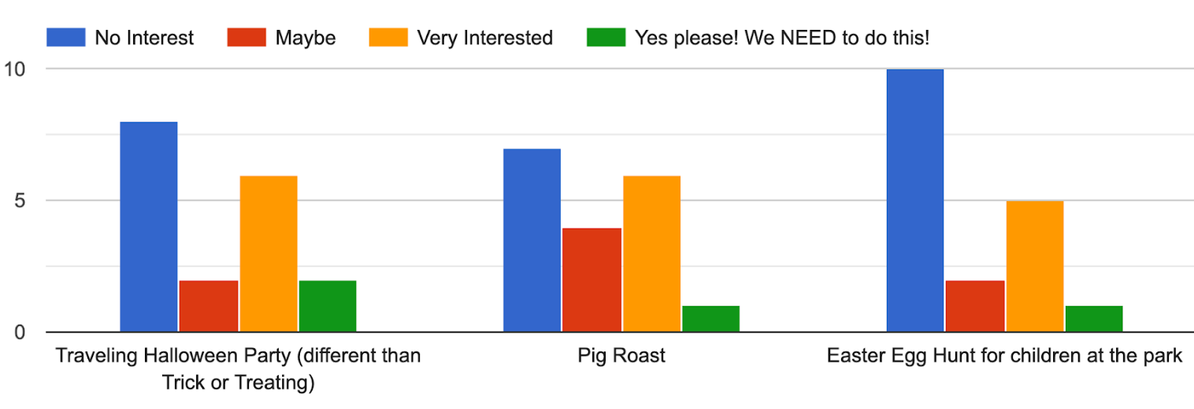

  - Seeking a neighborhood activity coordinator – please contact a board member if interested.
- No discussion items requested from homeowners not on the board.
- Board Elections
  - New members – no one that is not on the board wanted to join the board.
  - No challenges to board positions.
  - Motion to elect current members for another year was carried.

Meeting adjourned at 7:38pm

